Success at Foundation – Key structures Knowledge Organiser

Opinion Future Past Conditional

Cute Puppies Fall Over
Old People Feel Chilly
Can Fathers Peel Oranges | 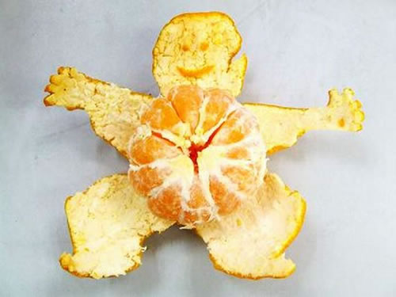
Chimpanzees Fling Orange Peels | 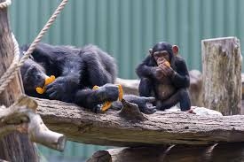
Opinions of the Future Conditionally Pass
Justify Justify Justify!

Me gusta + infinitive | I like to
Voy a + infinitive | I am going to
Decidí + infinitive | I decided to
Me gustaría + infinitive | I would like to
porque | Because
https://quizlet.com/_5i7u0k

Opinion
Me gusta + infinitive | I like to
Me gusta leer | I like to read
Me gusta ayudar | I like to help
Me gusta hacer | I like to do
Me gusta escuchar | I like to listen
Me gusta ir | I like to go
Future
Voy a + infinitive | I am going to
Voy a hacer | I am going to do
Voy a ir | I am going to go
Voy a visitar | I am going to visit
Voy a hacer | I am going to do
Voy a viajar | I am going to travel
Past
Decidí + infinitive | I decided to
Decidí ir | I decided to go
Decidí aprender | I decided to learn
Decidí comprar | I decided to buy
Decidí hacer | I decided to do
Decidí salir | I decided to go out
Conditional
Me gustaría + infinitive | I would like to
Me gustaría ir | I would like to go
Me gustaría visitar | I would like to visit
Me gustaría tener | I would like to have
Me gustaría comprar | I would like to buy
Me gustaría aprender | I would like to learn
Justify
Porque es | Because it is
puesto que son | Given that they are
dado que me gusta | Given that I like
ya que es | Since it is
Porque son | Because they are
Puesto que es | Given that it is

